Multiple Choice

1. The site of implantation in a human female is the:
2. Fallopian tube
3. Cervix
4. Uterine wall
5. Ovary.
6. The testes of humans are usually found outside the body. The main reason for this is:
7. To allow freedom of movement of the testicles
8. To maintain an optimum temperature for sperm production
9. To ensure that testosterone is being produced
10. To keep the testes cooler than the core body temperature.
11. The purpose of a ‘Pap’ smear is to achieve early diagnosis of:
12. Cervical cancer
13. Ovarian cancer
14. Uterine cancer
15. Ovarian cysts.
16. The hormone that initiates ovulation is
17. Progesterone
18. Testosterone
19. Follicle stimulating hormone
20. None of the above.
21. Sperm undergo the final stages of their maturation in the:
22. Seminiferous tubules
23. Testes
24. Epididymis
25. Vas deferens.
26. The middle piece of a spermatozoa consists mainly of:
27. DNA
28. The flagella
29. Mitochondria
30. Cell membrane.
31. During the process of oogenesis, the second polar body is released when:
32. The first meiotic division is completed
33. Fertilisation occurs
34. Ovulation occurs
35. Anaphase II is completed.
36. The hormone prolactin:
37. Helps maintain the endometrium
38. Stimulates milk production
39. Helps develop secondary sex characteristics
40. Maintains the corpus luteum during the early stages of pregnancy.
41. Which of the following statements about a ‘typical’ menstrual cycle is correct?
42. Ovulation occurs on Day 14
43. The onset of uterine bleeding is taken to be the first day of the cycle
44. Progesterone concentration in the blood is higher in the first half of the cycle
45. The endometrium is more vascular in the second half of the cycle
46. The corpus luteum is at its largest between days 10 to 14
47. (i), (ii) & (iii) only
48. (i), (ii), & (iv) only
49. (iii), (iv) & (v) only
50. (i), (iii) & (iv) only.

10. Which of the following statements is not true?

1. The cortical reaction occurs to prevent a second sperm from entering the egg.
2. A blastocyst is a hollow ball of cells that embeds into the uterine wall using enzymes to digest and penetrate the lining.
3. The four-cell stage is most likely to occur when the developing embryo is in the uterus.
4. Skin and nerve tissue develop from the ectoderm (one of the three primary germ layers).

Short Answer

Question 11 refers to the following diagram of the male reproductive system.

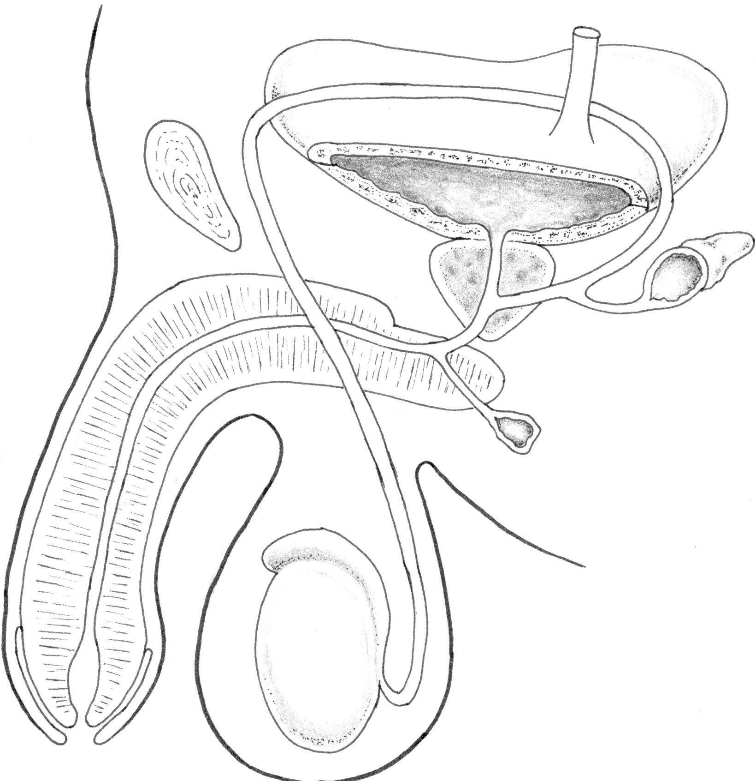

##### X

(i) Label the diagram in the spaces provided. (3)

(ii) What is the function of the tube labelled X? (2)

12. Giving examples, distinguish between primary and secondary sexual characteristics. (2)

13. Describe the role of follicle stimulating hormone in the male and female reproductive systems. (2)

Question 14 refers to the following diagram of the ovary.

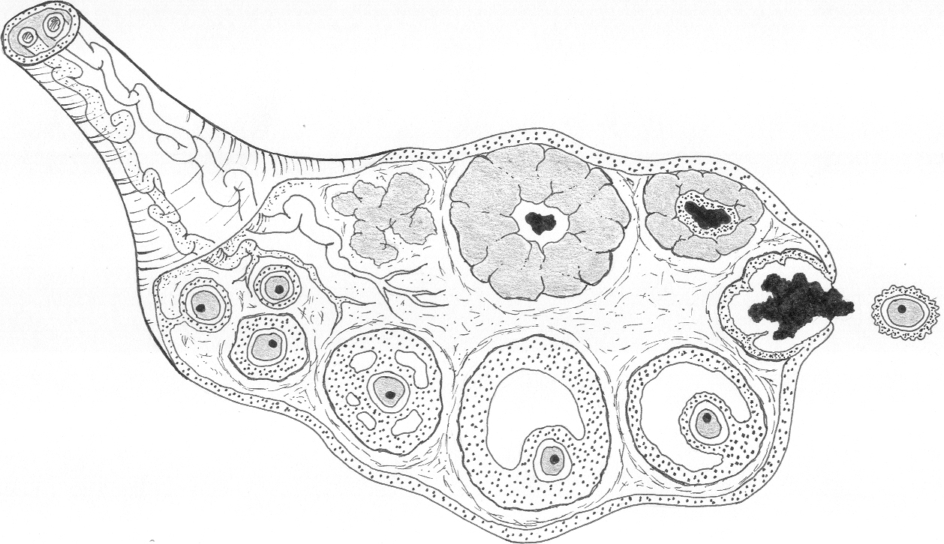

**Z**

**Y**

(i) Name the structure labelled Z and the main hormone that it secretes. (2)

(ii) What is the name of the structure labelled Y (cell layer around the ovum)? (1)

(iii) Explain how a sperm is able to penetrate Y. (2)

15. Below is a flow diagram showing the various stages of spermatogenesis.

Spermatogonium

**X**

**W**

1. Write the name of the two cell types (W and X) in the boxes provided on the diagram. [2]
2. Clearly indicate on the diagram when the first and second meiotic divisions occur. [2]

16. Below is a section from a pamphlet that comes with a home pregnancy test. Read it and then answer the questions that follow on the next page.

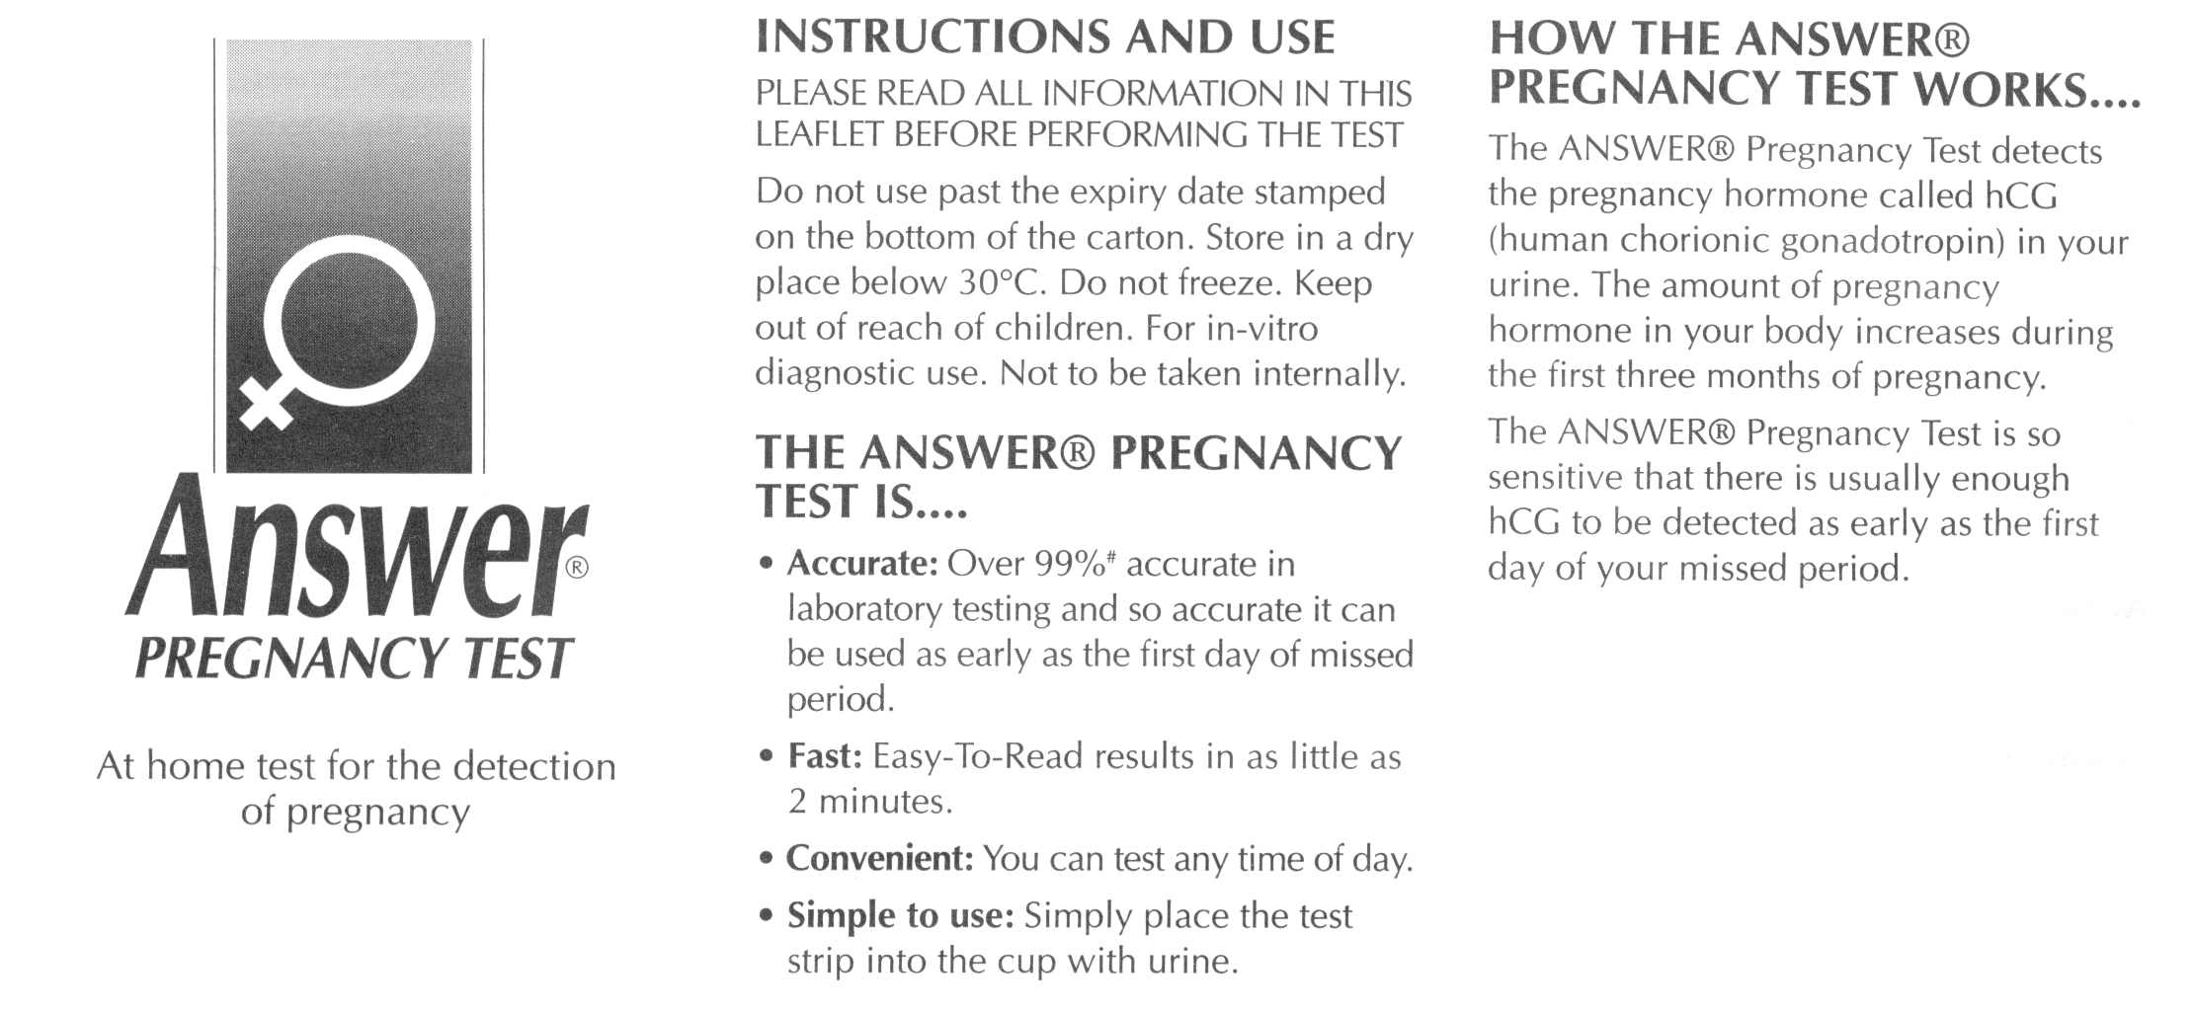

(i) The test claims to be 99% accurate in laboratory testing. Give one reason why it may not be so accurate when used in the home. (1)

(ii) Explain why hCG is a reliable indicator that a woman is pregnant. (2)

(ii) Another section of the pamphlet (not included above) states that a pregnant woman should limit her consumption of alcohol. Explain why this is good advice. (2)

17. Discuss the role of each of the following blood vessels

* Umbilical artery
* Ductus arteriosus (2)